**The Tableau HR Scorecard: Measuring Success In Talent Management**

**1.Introduction**

**1.1.Overview:**

Problem Understanding, also known as Problem Definition or Problem Identification, is the initial and critical phase of any data analysis or problem-solving process. It involves gaining a clear and comprehensive understanding of the problem at hand, its context, scope, and objectives.

**1.2.Purpose:**

The business requirement of The Tableau HR Scorecard: Measuring Success in Talent Management is to provide a comprehensive and effective framework for measuring and evaluating the success of talent management strategies within an organization. The primary goal is to enable HR professionals and business leaders to track and analyze key performance indicators (KPIs) related to workforce planning, recruitment, retention, and development. We can do so by creating interactive dashboards and reports, making data-driven decisions and creating forecasting models for future performance. The ultimate goal is to gain insights and improve performance through data visualization techniques.

**2.Problem Statement & Design thinking**

1. Improved employee engagement: The HR Scorecard can help organizations measure and improve employee engagement by providing insights into employee satisfaction, retention rates, and other key metrics. This, in turn, can lead to a more engaged and motivated workforce, which can have a positive impact on productivity and overall business performance.

1. Enhanced diversity and inclusion: The HR Scorecard can also help organizations improve their diversity and inclusion efforts by tracking metrics such as the diversity of their workforce, the representation of different groups in leadership positions, and the effectiveness of diversity and inclusion training programs. By identifying areas where they need to improve and taking action to address them, organizations can create a more inclusive work environment that values diversity and promotes equal opportunities.

**Business Model/Impact**

1. Improved HR performance: By tracking and analyzing key HR metrics, The Tableau HR Scorecard can help organizations identify areas where they need to improve and take proactive steps to address them. This, in turn, can lead to improved HR performance, including increased employee engagement, improved retention rates, and enhanced diversity and inclusion efforts.
2. Enhanced decision-making: The Tableau HR Scorecard can provide HR professionals and business leaders with valuable insights into HR performance, which can help them make informed decisions and take proactive steps to improve business performance. This can include identifying areas where they need to invest in training and development programs, improving recruitment and retention strategies, and optimizing workforce planning and management.

**2.1 Empathy Map**

**Ideation and Brainstorm:**

**Result:**

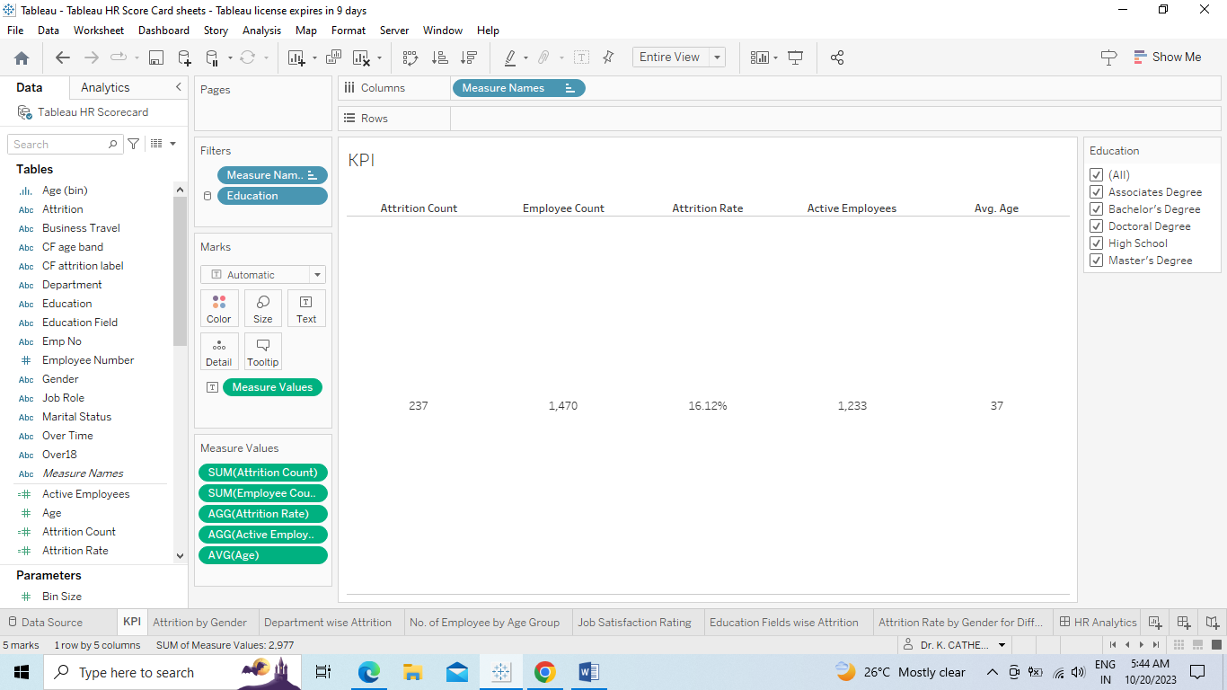

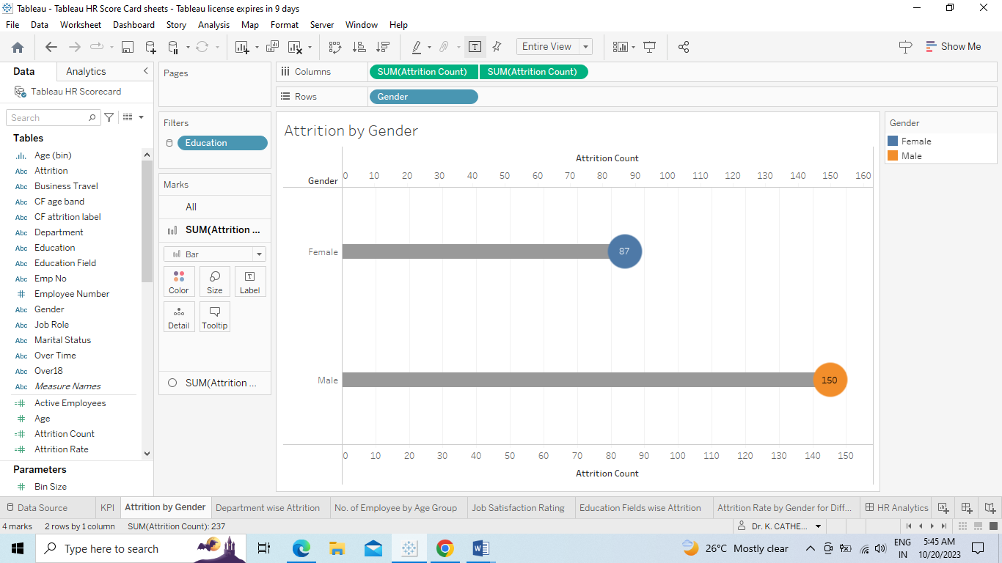

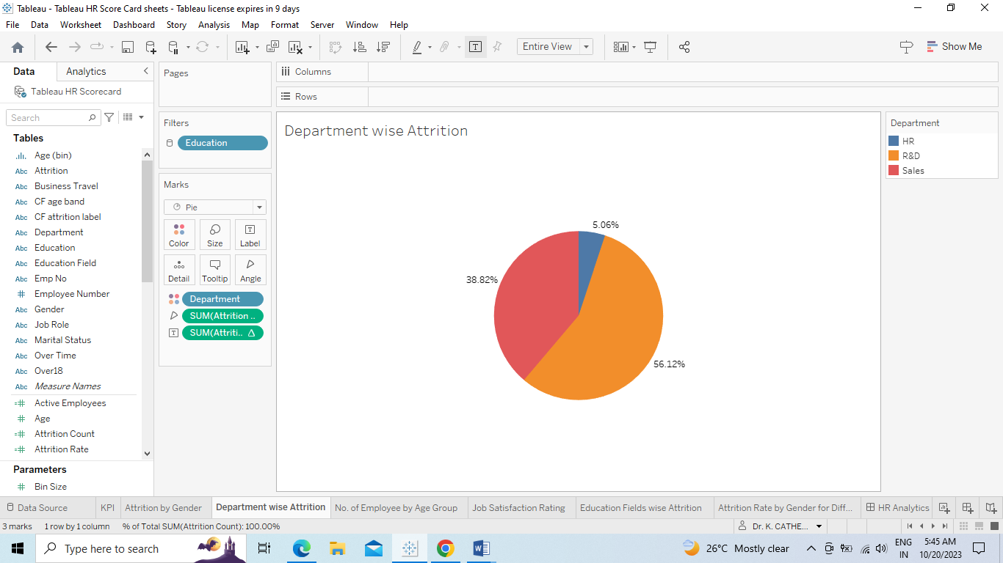

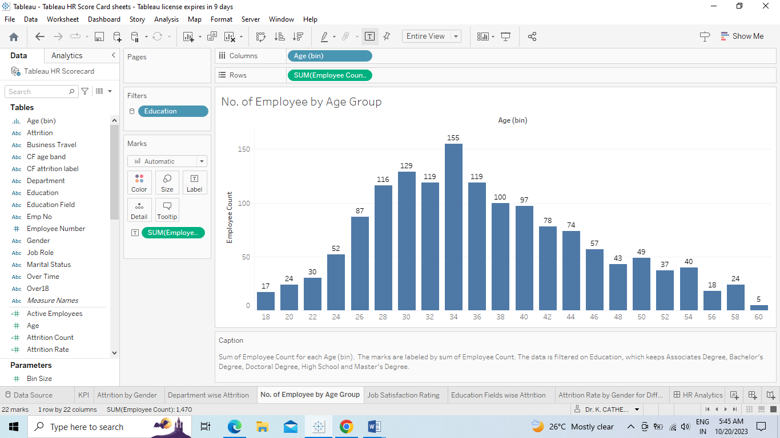

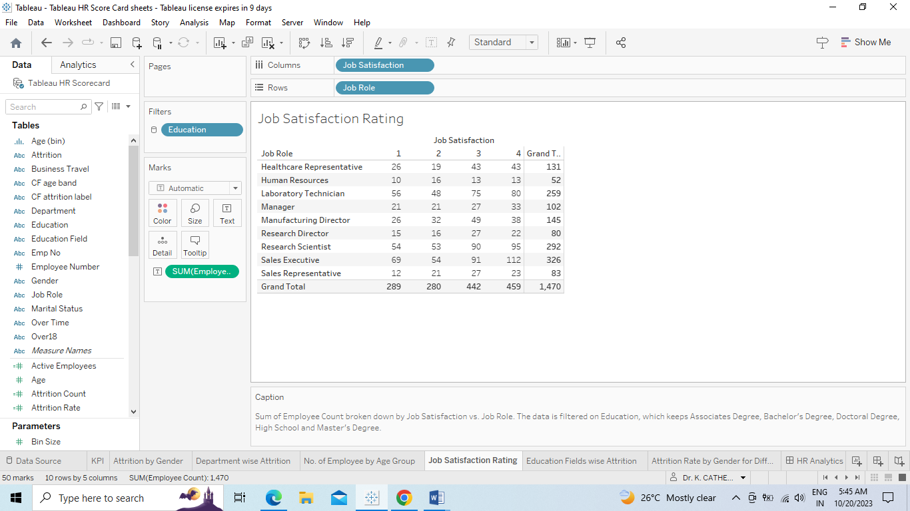

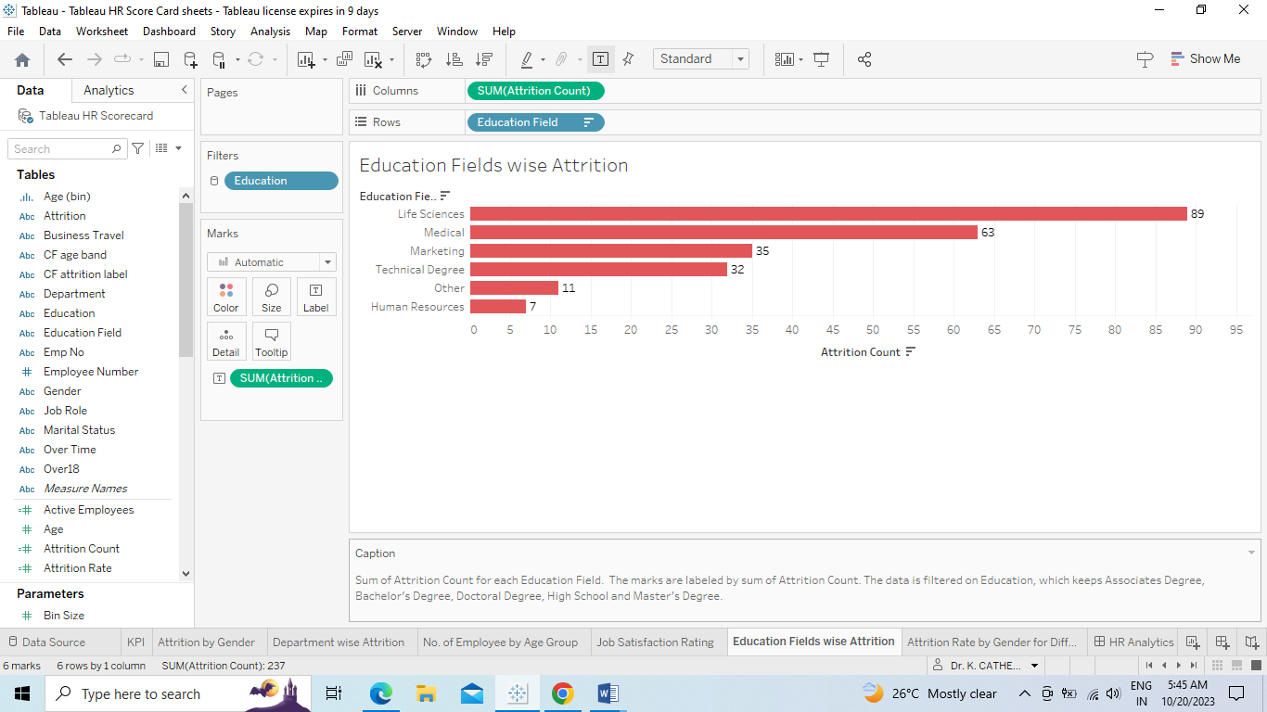

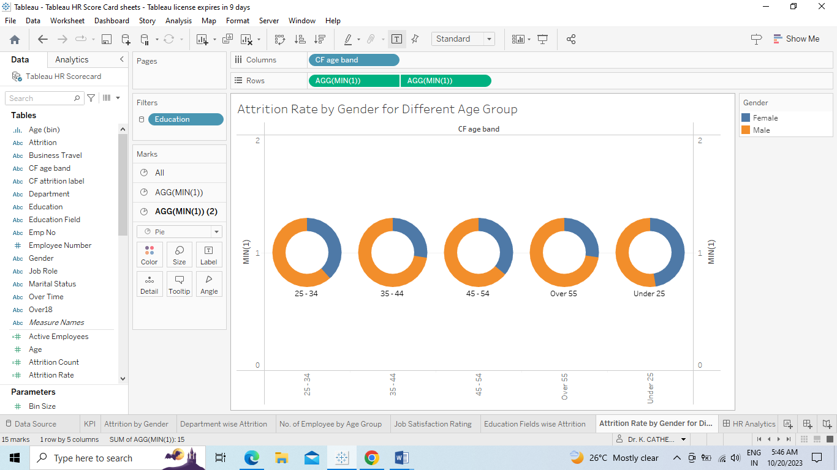

**Dash Board**

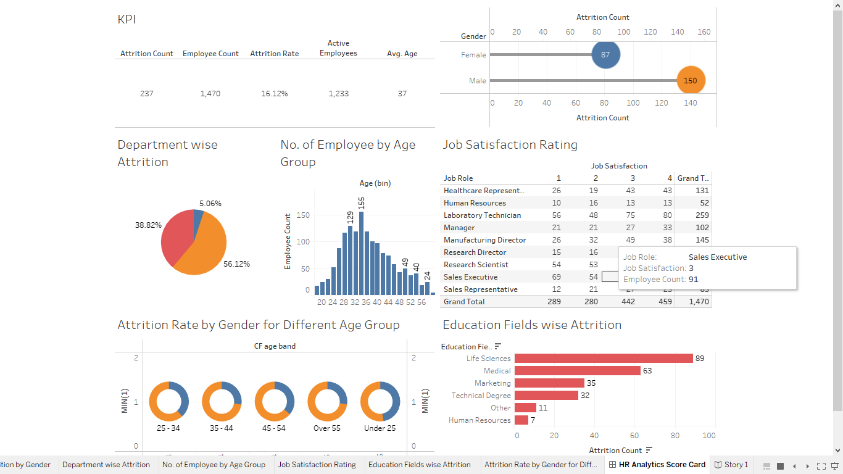

**Story**

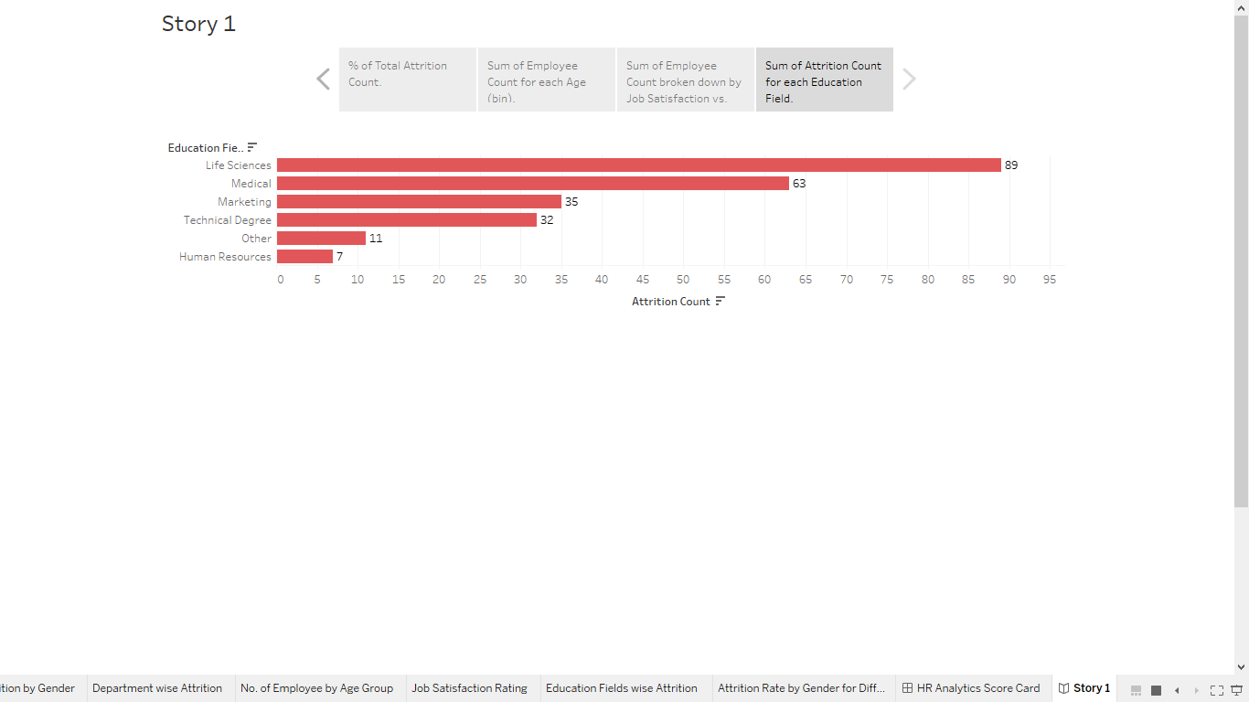

**Advandages&Disadvandages**

**Advantages:**

.1Data Visualization: Tableau provides powerful visualization tools, allowing HR professionals to represent complex HR data in easy-to-understand charts, graphs, and dashboards.

2.Real-time Analytics: Tableau allows real-time data analysis, enabling HR teams to make quick decisions based on the most recent information about talent metrics and performance.

3.Customization: Users can create customized dashboards tailored to their specific HR needs, making it easier to track key performance indicators (KPIs) and metrics relevant to talent management.

Disadvantages:

1.Complexity: Tableau can be complex for beginners, requiring a learning curve to master its advanced features and functionalities, which might be challenging for HR professionals with limited technical expertise.

2.Cost: Tableau licenses and subscriptions can be expensive, especially for large organizations. Budget constraints might limit access to Tableau's full range of features.

3.Data Security: Ensuring data security and privacy is crucial. Mishandling sensitive HR data within Tableau can lead to security breaches if not appropriately managed and secured.

**Application:**

It seems like you're mentioning Tableau, HR Scorecards, and Talend Management Application. Tableau is a popular data visualization tool, HR Scorecards are used to measure HR metrics, and Talend is an open-source data integration tool. If you have specific questions about any of these tools or need help with a particular aspect, feel free to ask!

**Conclusion:**

I don't have access to specific documents, including the Tableau HR Scorecard you mentioned. However, if you can provide specific points or questions related to Talent Management or HR Scorecards, I'd be happy to help answer or discuss them with you.

**Future Scope:**

The Tableau HR Scorecard is a powerful tool for measuring success in talent management. It allows organizations to track key performance indicators (KPIs) related to HR and workforce management. As for the future scope, the continued advancement of data analytics and artificial intelligence in HR management suggests that tools like Tableau will play a significant role. Organizations will likely rely more on data-driven insights to make informed decisions about talent acquisition, retention, and development. This trend indicates a growing need for professionals who can interpret HR data effectively and implement strategies based on those insights. If you're interested in this field, acquiring skills in data analysis, visualization, and HR management could be valuable for your future career prospects.